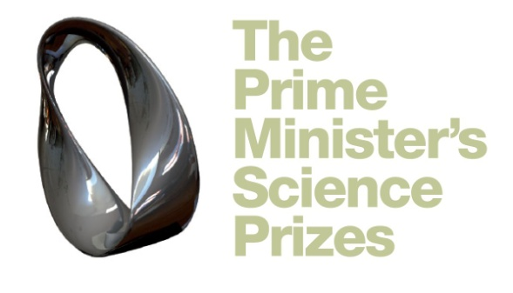

Prime Minister’s Future Scientist Prize Application Form
This Prize is for a Year 12 or year 13 student who has carried at an excellent science/technological/engineering project.

Full name of student:
Address:
Email: (do not use a school email address)
Home Phone number:
Cellular number:
School: |  | Year | DOB
What subjects are you studying at school?

What are you planning to study at a tertiary level?

What was your overall mark for NCEA1 or NCEA2 | NCEA 1 NCEA 2 OTHER QUALIFICATIONS  Achieved Achieved  Merit Merit  Excellence Excellence
What science subjects are you studying?

Has this research you are submitting won any awards? for example at your regional S&T Fair. | Yes | No | Please list awards

You must include the following as part of your application

Executive Summary of your research (1 page or 500 words) | □
Report (5 pages maximum)  Please follow the guidelines for writing your report which are on the website. | □
Please include scanned copies of your log book or journal. | □
Supplementary material relating to your research such as photographs, graphs, raw data, ethics forms (if applicable) | □
Nominator Form | □
Mentor Form (if applicable) | □
Student Declaration Form | □
Student Research Form | □
3 minute video of you talking about your project. This will help support your report.  When you upload the video make it ‘unlisted’ and this will mean that those with the link will be able to see it.  Please provide link: | □

All material must be sent to Debbie.woodhall@royalsociety.org.nz by 5pm on Tuesday 30 October. If the file is very big then please use Dropbox www.dropbox.com

