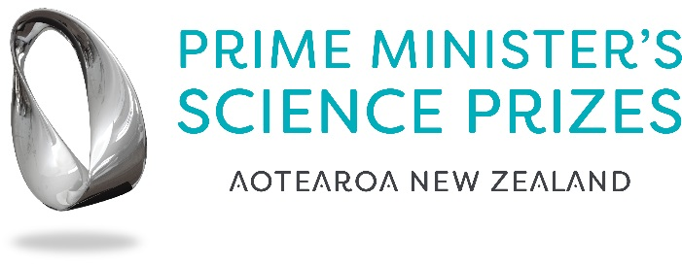

Prime Minister’s Emerging Scientist Prize

Summary of Research Form
Include addressing the three criteria in the summary which must be a maximum of 1,000 words.

Please send this back to pmscienceprizes@royalsociety.org.nz by 5pm on Thursday 10 October 2019.

