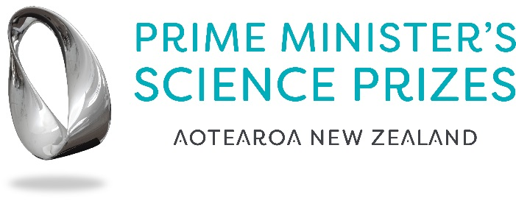

Prime Minister’s Emerging Scientist Prize

Summary of Research Form
Include addressing the three criteria in this summary. Maximum of 1,000 words.

- The research carried out by the applicant is leading edge in its field;
- The research has already, or is likely to result in the generation of valuable new knowledge in the field, or have wider impact;
- The applicant is able to effectively communicate their research.

Please send this back to pmscienceprizes@royalsociety.org.nz by 5pm on Friday 9 October 2020.

